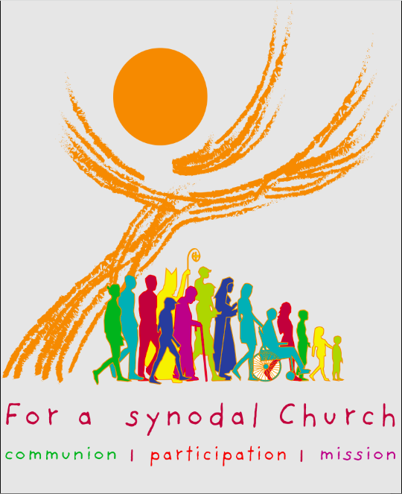
“Let anyone who has an ear listen to what the Spirit is saying to the churches.” (Rev 2:7)
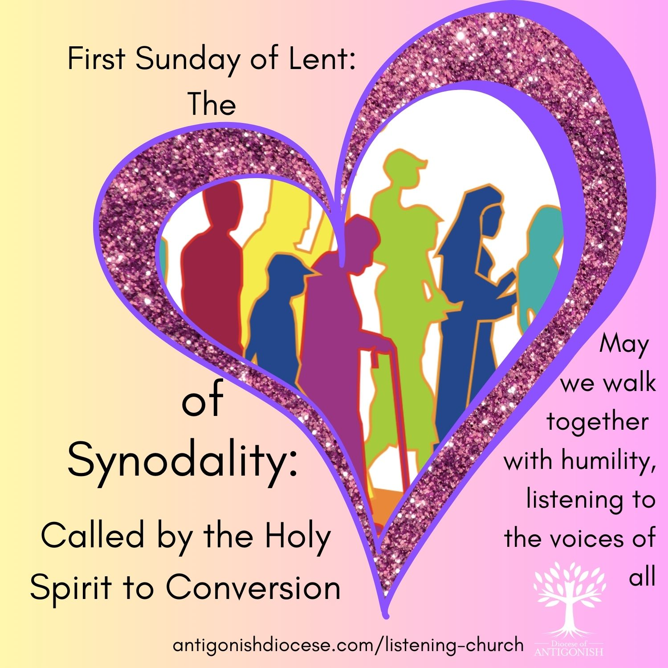
Bulletin Notices and Prayers of the Faithful for Lent 2026
For First Sunday of Lent: February 22
Bulletin Notice:
What is Synodality?
From the Final Document:
“The terms ‘synodality’ and ‘synodal’ derive from the ancient and constant ecclesial practice of meeting in synods … Synodality is the walking together of Christians with Christ and towards God’s Kingdom, in union with all humanity.”
“Synodality is not an end in itself. Rather, it serves the mission that Christ entrusted to the Church in the Spirit … By appreciating all charisms and ministries, synodality enables the People of God to proclaim and witness to the Gospel … Synodality and mission are intimately linked: mission illuminates synodality and synodality spurs to mission.”
Synod Reports and Resources are available online:
www.antigonishdiocese.com/listening-church
Prayers of the Faithful
For the Church: That during this slow journey, we may listen to the Holy Spirit and grow as a synodal Church, walking together with humility and listening to the voices of all, especially the marginalized. We pray to the Lord.

For World Leaders: That in times of temptation to power, they may choose the path of service, solidarity, and justice for all people. We pray to the Lord.

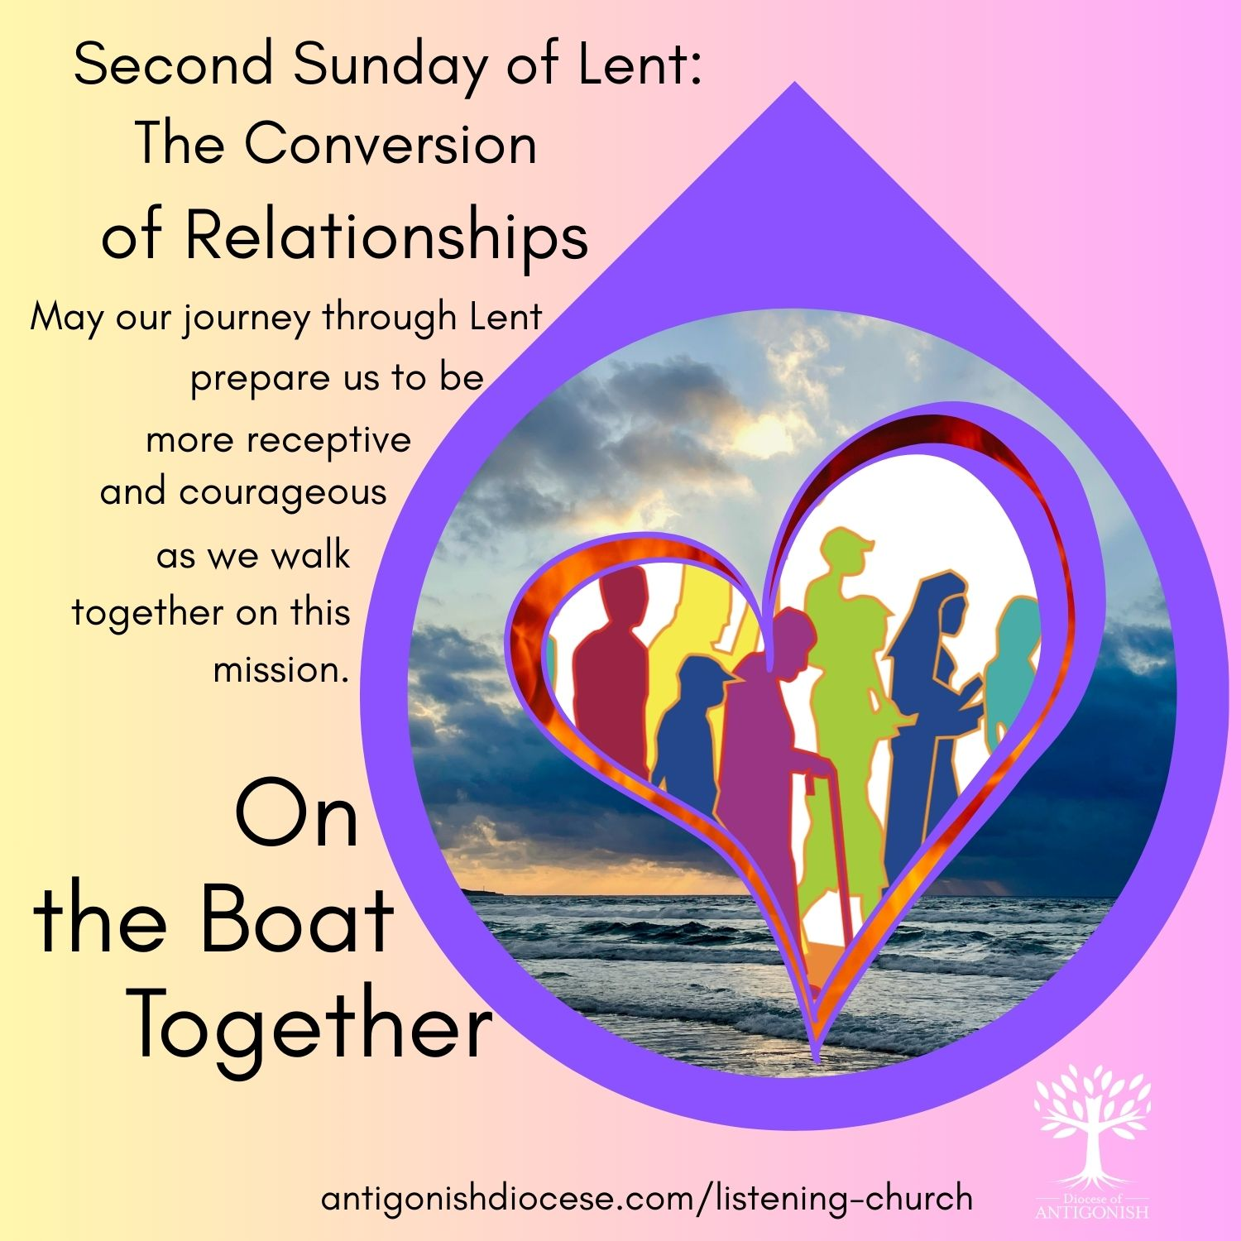
For Second Sunday of Lent: March 1
Bulletin Notice:
Embracing Synodality
through Faith, Discipleship, and Transfiguration
Just as Abram responded to God's call with faith and obedience, and Jesus was transfigured to reveal God's glory, we too are called to be transfigured through our participation in the Church’s mission.
Synodality calls us to be a community that listens deeply to the needs, charisms, and voices of all the baptized, especially those on the margins.
We are called to foster a synodal Church that encourages more lay ministries, supports community discernment, and responds creatively and courageously to the needs of our people.
May our journey through Lent prepare us to be more receptive and courageous as we walk together on this mission.
Synod Reports and Resources are available online:
www.antigonishdiocese.com/listening-church

Prayers of the Faithful
For the Synod Process: That the glory of the Transfiguration may inspire our listening hearts, helping us to discern the signs of the times and transform our Church into a more welcoming, synodal community. We pray to the Lord.

For Those Facing Struggle: That the light of Christ may bring hope to those facing poverty or despair, and that our slow acts of charity may reflect God's compassionate love. We pray to the Lord.
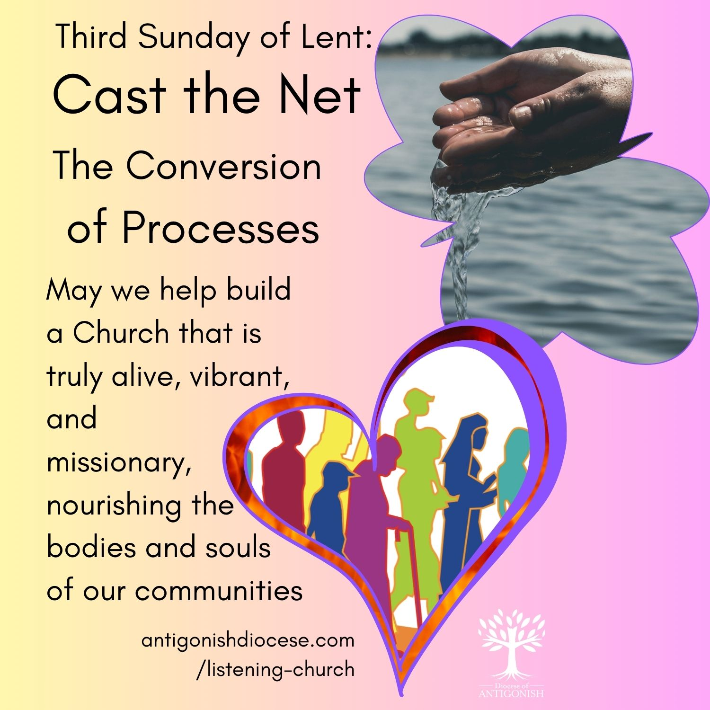
For Third Sunday of Lent: March 8
Bulletin Notice:
Embracing Synodality through the Lens of Scripture
The story of the Samaritan woman at the well reveals Jesus as the source of "living water," a symbol of the grace that quenches our spiritual thirst and calls us into authentic encounter and conversion. The Scriptures remind us that life-giving water—God’s grace—flows through community. Just as Jesus offered the Samaritan woman a new way of seeing and living, we are called to create spaces where all members of the Church can encounter Christ, be heard, and participate fully in the decision-making processes. This includes revitalizing our participatory bodies—diocesan councils, parish councils, and other structures—ensuring they reflect the diversity and richness of our communities.
Let us be inspired by the Gospel’s call to renewal and conversion. By doing so, we help build a Church that is truly alive, vibrant, and missionary.
Synod Reports and Resources are available online:
www.antigonishdiocese.com/listening-church

Prayers of the Faithful

For Open Dialogue: That as Jesus broke barriers to speaking with the Samaritan woman, our Church may actively listen to all people, creating spaces of dialogue, understanding, and reconciliation. We pray to the Lord.

For Our Community: That we can recognize Christ in one another and work together to build a more inclusive parish family, rooted in mutual respect and shared mission. We pray to the Lord.

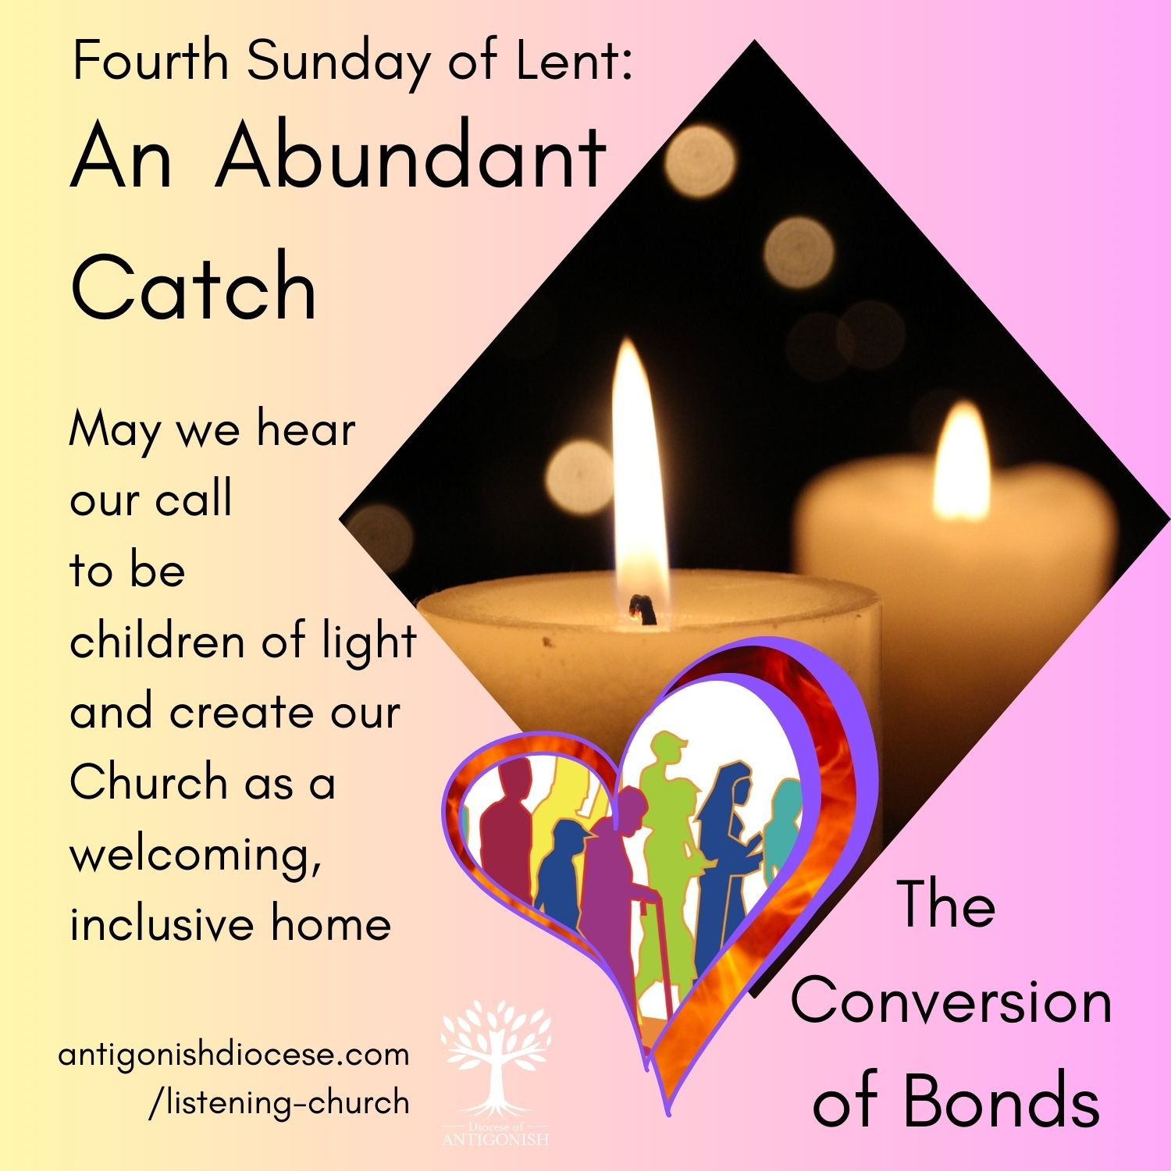
For Fourth Sunday of Lent: March 15
Bulletin Notice:
Being Children of Light
Scripture challenges us to see with the eyes of faith and to recognize the ways in which we ourselves may be blind to the needs, gifts, and callings within our Church communities. We are also reminded that
God looks beyond outward appearances to the heart, calling us to live as "children of light."
A synodal Church is one that walks together in humility and openness, listening to the Spirit and to one another—whether in our parishes, dioceses, or the universal Church. The image of the Church as a home of hospitality and encounter aligns with the synodal journey: a space where diverse voices are heard, where differences are appreciated as opportunities for mutual enrichment, and where the Spirit guides us in discernment.
Let us ask ourselves: Are we truly seeing with the eyes of faith? Are we listening as a Church called to be a home of welcome, a school of communion, and a pilgrim community on mission? As we continue along this Lenten path, may the Light of Christ dispel our spiritual blindness, inspiring us to be a more synodal Church—one that walks together in hope, rooted in love and open to the Spirit’s guiding.
Synod Reports and Resources are available online:
www.antigonishdiocese.com/listening-church

Prayers of the Faithful
For Spiritual Sight: That the Lord may open our eyes to see our own limitations, that we may move away from clericalism and embrace a truly synodal way of being Church where everyone has a part. We pray to the Lord.

For Joy in Repentance: That this "Laetare" Sunday may fill us with joy, and that we may turn away from division and toward a deeper, shared communion. We pray to the Lord.

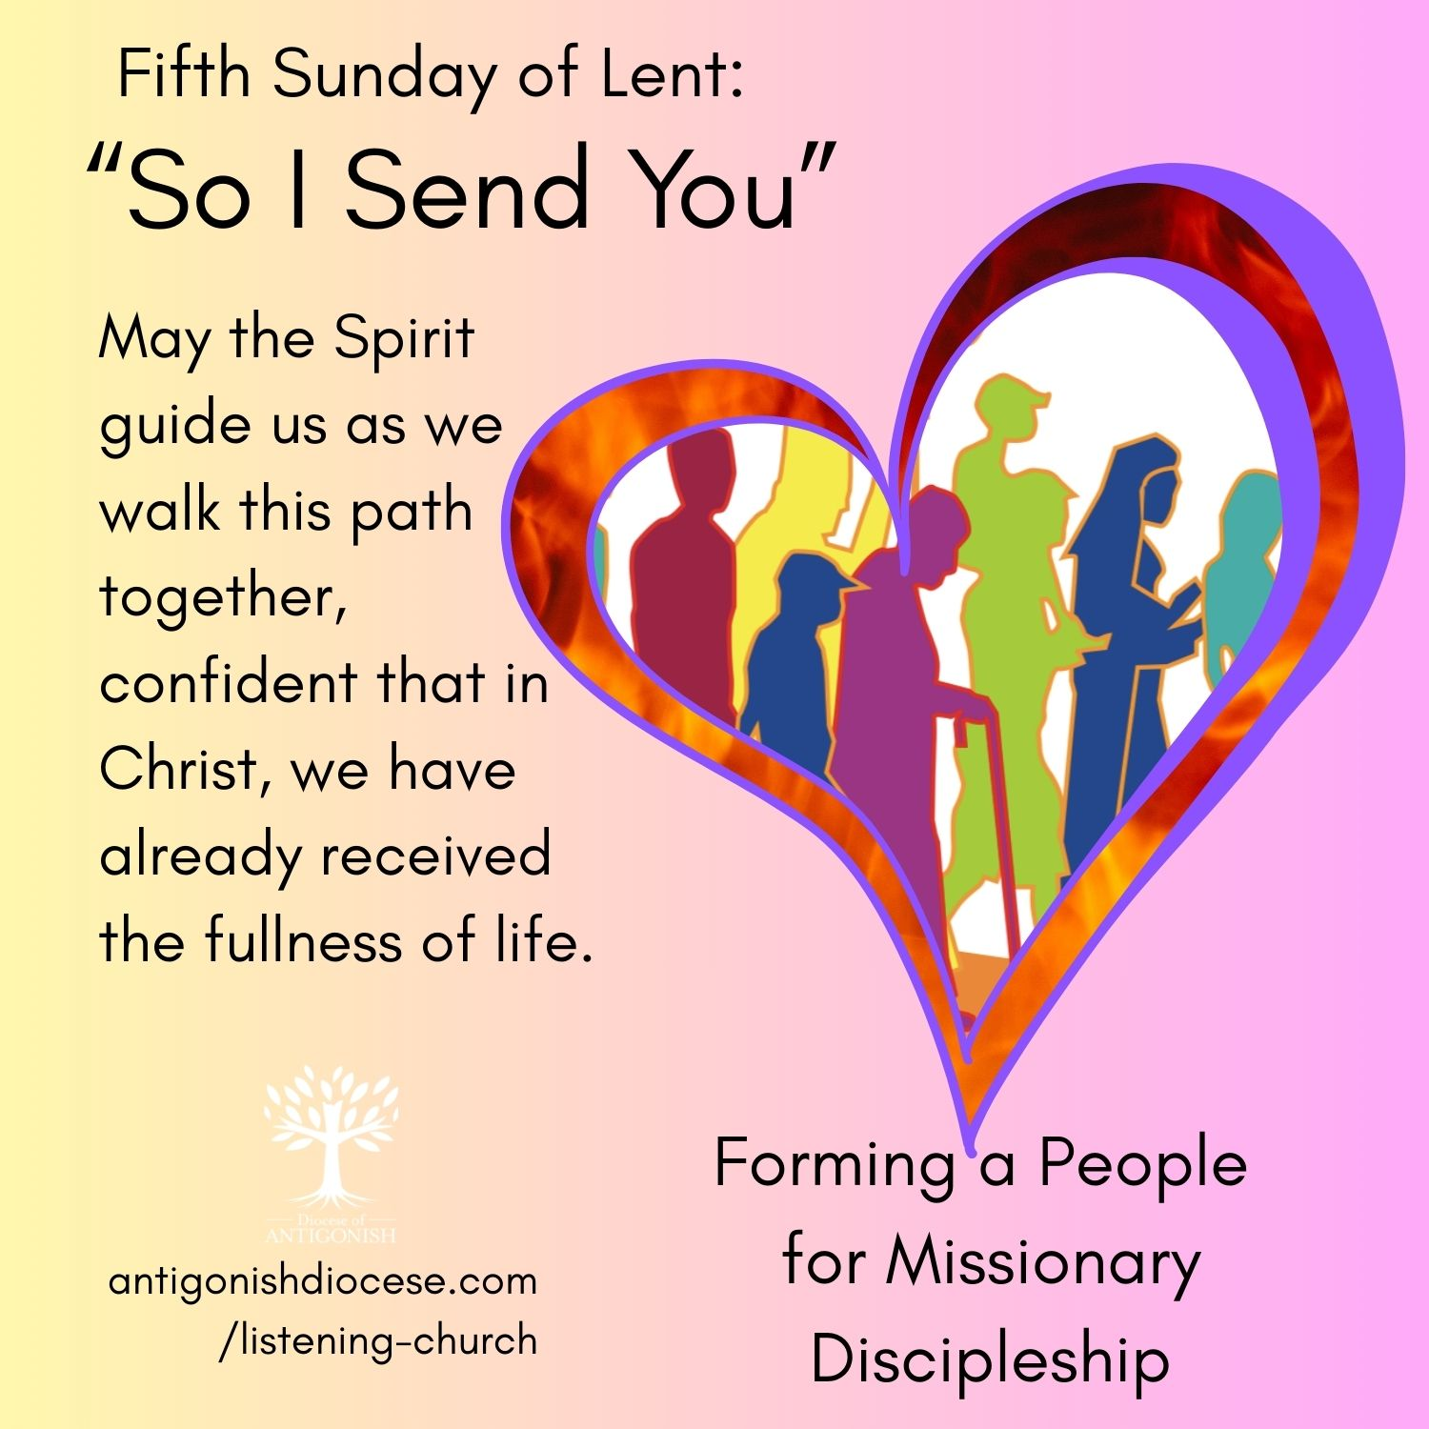
For Fifth Sunday of Lent: March 22
Collection Sunday, Development and Peace
Bulletin Notice
A ‘Common and Shared Formation’
Scripture challenges us to consider what it means to be a Church that embodies resurrection—alive, vibrant, and committed to life-giving missions in the world. Synodality calls us to walk together, to listen deeply, and to discern the Spirit’s guidance as a community. It is about shared participation—men and women, laity and clergy, young and old—collaborating in the mission of the Church. The synodal process emphasizes a “common and shared formation,” where every member’s voice contributes to the discernment of how we can more effectively live the Gospel. It recognizes that the Spirit dwells within all of us, animating our collective journey of faith, hope, and love. As we journey through Lent towards Easter, let us renew our commitment to be a synodal Church—one that listens, learns, and acts together, inspired by the Spirit of resurrection. Let us be open to conversion, to growth in love, and to the collaborative discernment that shapes our mission. In doing so, we become a Church that truly embodies the life, hope, and renewal promised in these sacred texts.

Prayers of the Faithful

For New Life in the Church: That as Jesus called Lazarus, he may call our Church to rise from indifference and, through the synodal process, renew our commitment to mission and service. We pray to the Lord.

For Victims of Injustice: That our slow sacrifices may help us stand in solidarity with those suffering from injustice, working together for a more just and loving world. We pray to the Lord.

