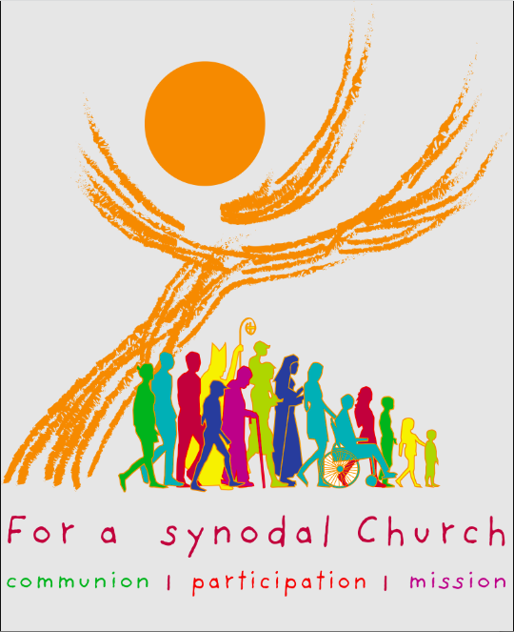
“Let anyone who has an ear listen to what the Spirit is saying to the churches.” (Rev 2:7)
Clergy/Parish Synod Resource for Lent 2026
You are invited during Lent to begin and continue your Synodal journey, engaging with your parish, committees, and community.

Promotional Resources:
- Poster for printing/Graphics for social media – available now
- Synod Prayer – cards available from the Chancery or Pastoral Centre
- Prayers of the Faithful
- Bulletin notices for each week of Lent and beyond (sent weekly in the diocesan Seven Ears of Grain and from the Pastoral Centre)

Weekly Lenten Themes:
Based on the Five parts of Final Document:

- Part One (#13-#48): “The Heart of Synodality”
- Part Two (#49-#78): “On the Boat, Together” = conversion of relationships
- Part Three (#79-#108): “Cast the Net” = conversion of processes
- Part Four (#109-#139): “An Abundant Catch” = conversion of bonds
- Part Five (#140-#151): “So I Send You” = first step is caring for the formation of all
What is Synodality?
From the Final Document:
“The terms ‘synodality’ and ‘synodal’ derive from the ancient and constant ecclesial practice of meeting in synods … Synodality is the walking together of Christians with Christ and towards God’s Kingdom, in union with all humanity.”
“Synodality is not an end in itself. Rather, it serves the mission that Christ entrusted to the Church in the Spirit … By appreciating all charisms and ministries, synodality enables the People of God to proclaim and witness to the Gospel to women and men of every place and time, making itself a “visible sacrament” (LG 9) of the fellowship and unity in Christ willed by God. Synodality and mission are intimately linked: mission illuminates synodality and synodality spurs to mission.”“And he said to them, “Go into all the world and proclaim the good news to the whole creation.” (Mk 16:15)
Synod Reports and Resources are available online:
www.antigonishdiocese.com/listening-church
www.synod.va
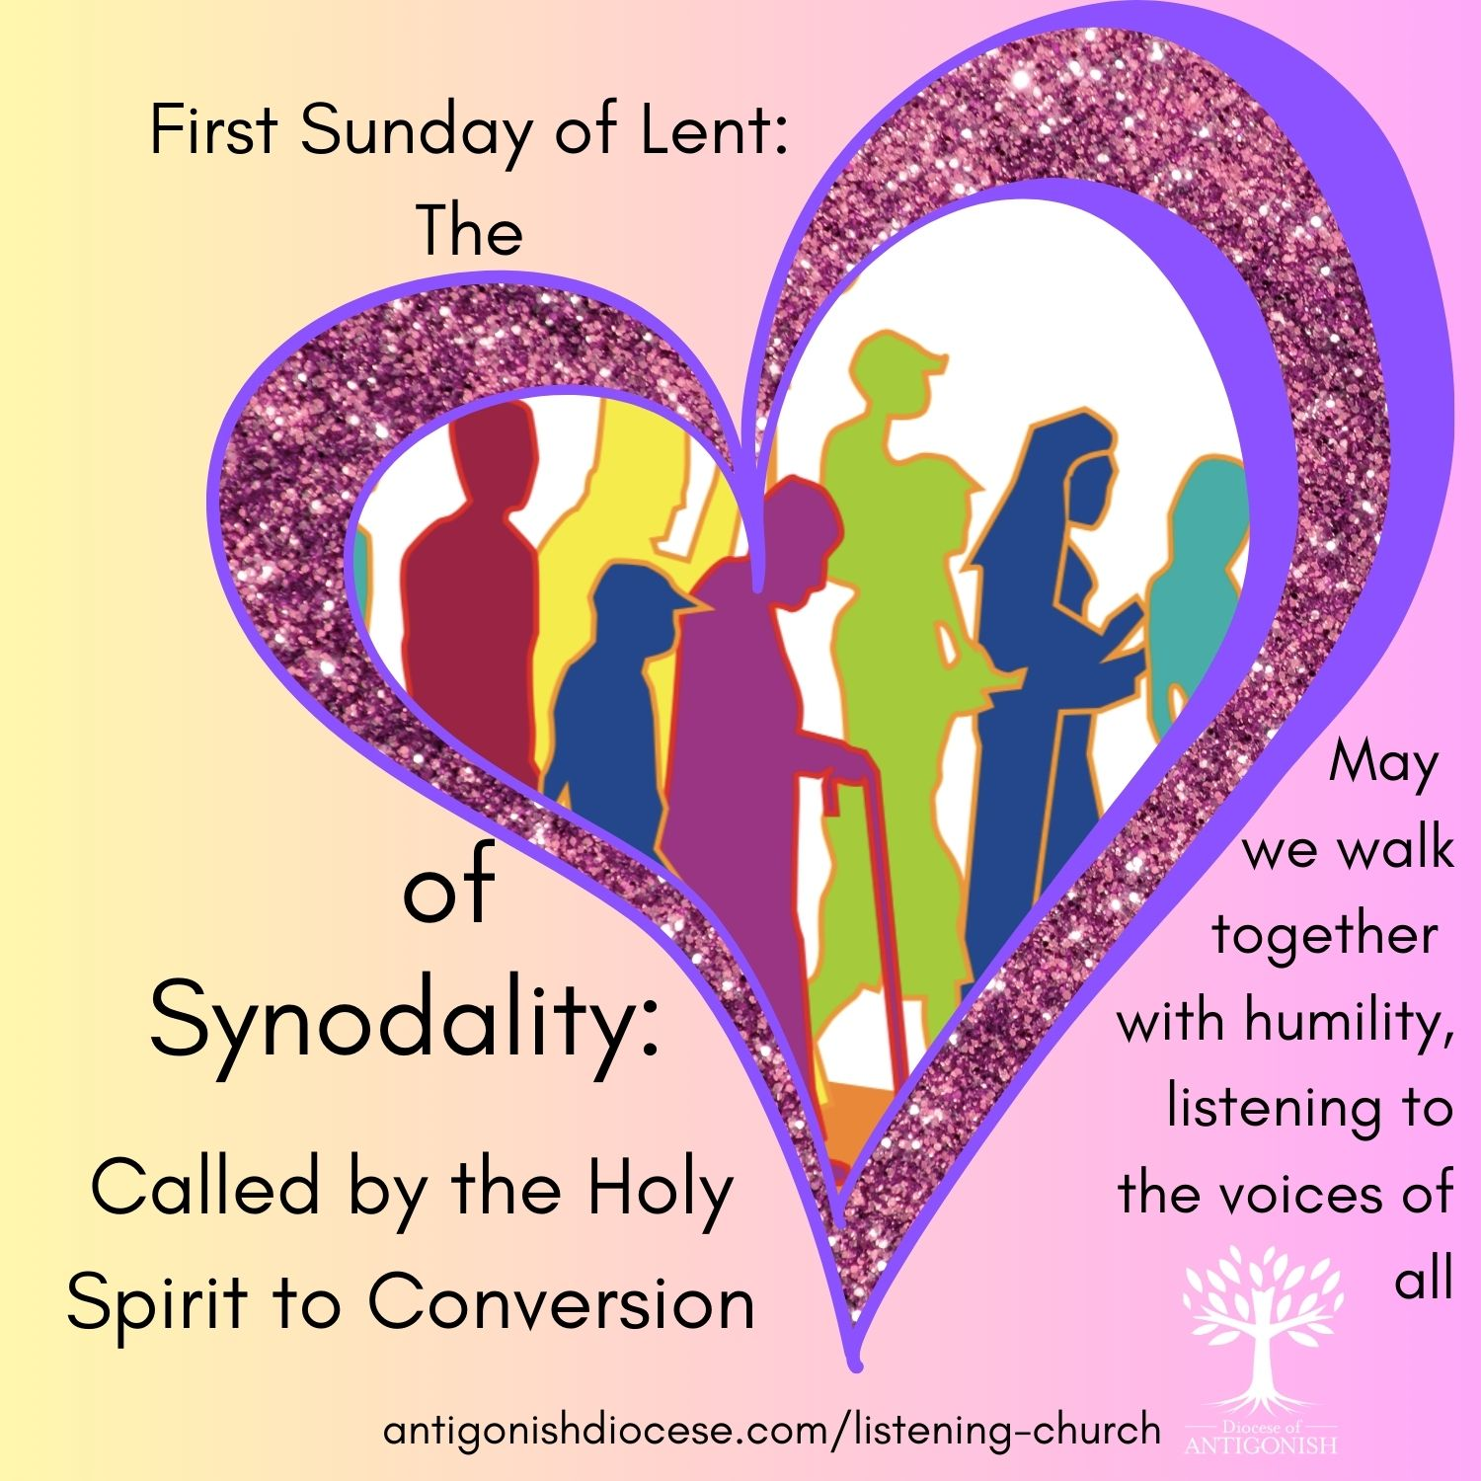
First Sunday of Lent: February 22
Part I - The Heart of Synodality
Called by the Holy Spirit to Conversion
Reflection/Homily Notes
As we enter into the season of Lent, our readings this Sunday invite us to reflect deeply on the themes of temptation, sin, and redemption. Genesis reminds us of the human tendency to stray from God's plan, while Romans emphasizes that through Christ, grace overflows where sin abounds. Jesus’ temptation in the desert, as recounted in Matthew, serves as a powerful example of resisting evil and trusting in the Word of God.
These themes are especially relevant as we consider our journey as a Church today. Lent is a time of renewal—an opportunity to examine our own temptations and sins, but also to renew our commitment to follow Christ more faithfully.
In this context, let us reflect on the importance of Synodality—the style of the Church that is rooted in journeying together as the People of God. Synodality is not merely about meetings or administrative structures; it is about a way of life—living and working as a community that listens, discerns, and acts together in the Spirit.
Just as Jesus models resistance to temptation through prayer, trust, and reliance on the Word of God, so too are we called to model a Church that listens actively to all its members, especially the marginalized and the poor. Synodality calls us to be a Church that journeys together, recognizing the diverse charisms given by the Holy Spirit for the building up of the Body of Christ.
In a world often tempted to resolve conflicts through force or division, our synodal spirituality offers a prophetic voice—one that promotes dialogue, humility, patience, and forgiveness. It invites us to be attentive to the signs of the times and to respond with humility and courage, fostering communion and mission.
As clergy, let us lead by example, embracing the spirit of Lent as a time of conversion—not only personally but also as a Church moving forward in synodality. May we be attentive to the Spirit’s guidance, welcoming the gifts of all God’s people, and journeying together toward the fullness of God's kingdom.
May this season deepen our commitment to be a synodal Church, a community that walks together in faith, hope, and love.
Prayers of the Faithful
For the Church: That during this slow journey, we may listen to the Holy Spirit and grow as a synodal Church, walking together with humility and listening to the voices of all, especially the marginalized. We pray to the Lord.

For World Leaders: That in times of temptation to power, they may choose the path of service, solidarity, and justice for all people. We pray to the Lord.
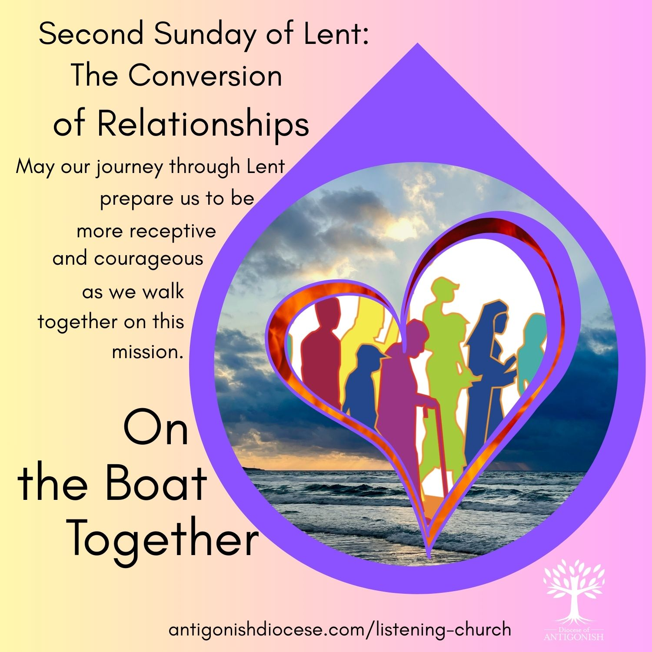
Second Sunday of Lent: March 1
Part II - On the Boat, Together
The Conversion of Relationships
Reflection/Homily Notes:
Embracing Synodality through Faith, Discipleship, and Transfiguration

As we gather on this Second Sunday of Lent, our readings invite us to deepen our understanding of faith, divine promise, and transformation. In Genesis, we hear God’s call to Abram—to leave his familiar land and trust in God's promises. Psalm 121 echoes our trust in divine mercy, while Paul’s letter to Timothy urges us to bear hardships for the Gospel, relying on God's grace. Finally, the Gospel recounts the Transfiguration of Jesus—a moment of divine revelation and transformation.
These themes resonate profoundly with our journey as a Church—a journey rooted in faith, marked by trust in God's promises, and called to transformation. Just as Abram responded to God's call with faith and obedience, and Jesus was transfigured to reveal God's glory, we too are called to be transfigured through our participation in the Church’s mission.
In the context of our current synodal journey, these readings remind us that listening—a core element of synodality—is essential to our life as a Church. Listening allows us to discern where God's Spirit is guiding us, much like Abram listened to God's call, and Jesus listened to the Father’s voice at the Transfiguration. Synodality calls us to be a community that listens deeply to the needs, charisms, and voices of all the baptized, especially those on the margins.
The synodal process involves discernment—identifying genuine pastoral needs, fostering a diversity of charisms, and creating ministries that serve the mission. This discernment process is rooted in listening, prayer, and community dialogue—echoing the divine listening and response we see in today’s scriptures.
As clergy, we are called to foster a synodal Church that encourages more lay ministries, supports community discernment, and responds creatively and courageously to the needs of our people. Just as the Transfiguration reveals Jesus' divine glory and invites us into a deeper understanding of our identity, the synodal process reveals the divine presence in our communal listening and shared mission.
Let us pray for the grace to be a transfigured Church—one that listens attentively, discerns faithfully, and responds boldly to the call of Christ in our time. May our journey through Lent prepare us to be more receptive and courageous as we walk together on this mission.
Prayers of the Faithful
For the Synod Process: That the glory of the Transfiguration may inspire our listening hearts, helping us to discern the signs of the times and transform our Church into a more welcoming, synodal community. We pray to the Lord.

For Those Facing Struggle: That the light of Christ may bring hope to those facing poverty or despair, and that our slow acts of charity may reflect God's compassionate love. We pray to the Lord.
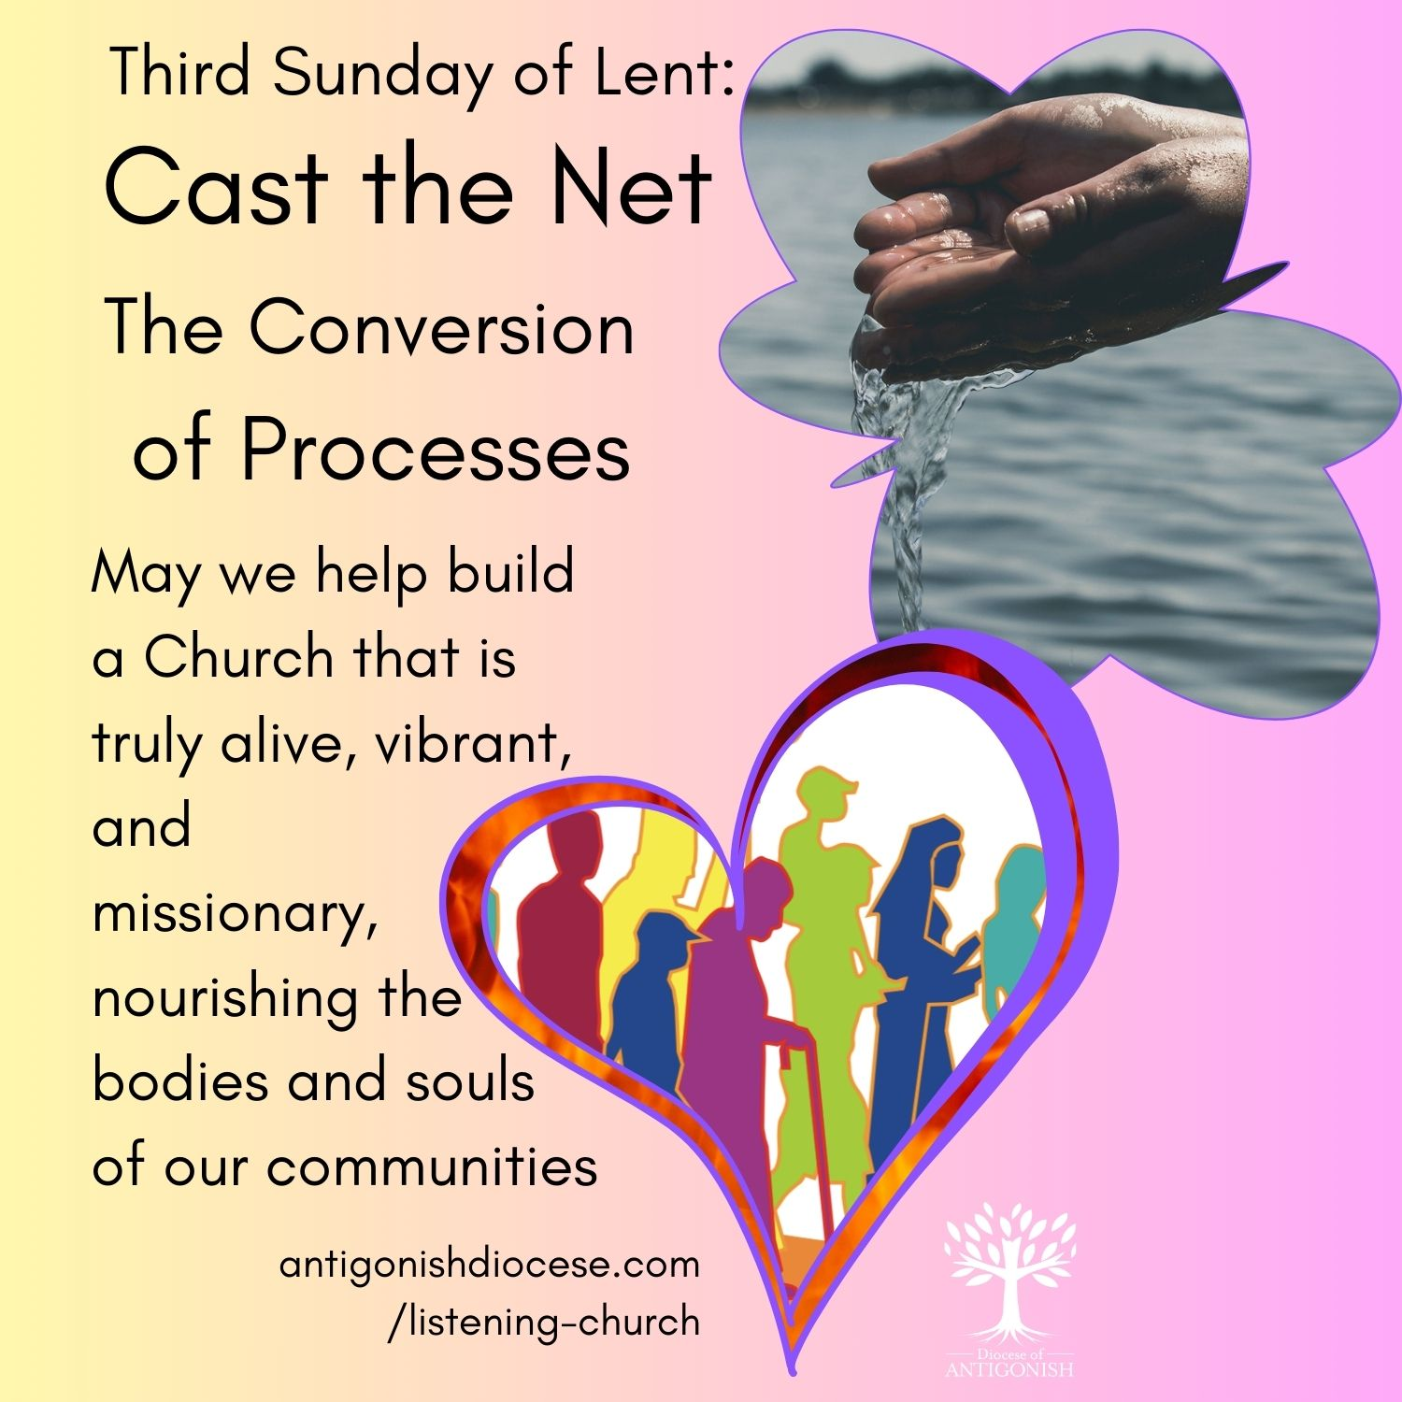
Third Sunday of Lent: March 8
Part III – “Cast the Net”
The Conversion of Processes
Reflection/Homily Notes:
Embracing Synodality through the Lens of Scripture
Today’s readings beautifully invite us into a deeper understanding of our journey as disciples and as a Church committed to ongoing conversion, renewal, and openness to the Spirit. The story of the Samaritan woman at the well (John 4) reveals Jesus as the source of "living water," a symbol of the grace that quenches our spiritual thirst and calls us into authentic encounter and conversion.
In the First Reading (Exodus 17), we hear of the Israelites’ grumbling for water in the desert—a reminder that even amidst hardship and doubt, God provides abundantly. The Psalm echoes this theme of listening for God's voice, urging us not to harden our hearts but to remain receptive.
Romans reminds us that through Jesus, we are justified and have hope—a hope rooted in love poured into our hearts. This love is not meant to be kept private but shared, lived out in community, and expressed through our participation in the life of the Church.
Connecting to Synodality
As clergy, we are called to foster a Church that embodies these themes—one that is truly synodal. A synodal Church is characterized by active listening, mutual participation, and shared discernment, rooted in the Spirit’s guidance. It is a Church where every baptized person, regardless of age, gender, or social status, is invited to contribute their charisms, experiences, and perspectives.
The Scriptures remind us that life-giving water—God’s grace—flows through community. Just as Jesus offered the Samaritan woman a new way of seeing and living, we are called to create spaces where all members of the Church can encounter Christ, be heard, and participate fully in the decision-making processes. This includes revitalizing our participatory bodies—diocesan councils, parish councils, and other structures—ensuring they reflect the diversity and richness of our communities.
Moving Forward
Let us be inspired by the Gospel’s call to renewal and conversion. In our roles as leaders, may we foster a culture of openness, accountability, and inclusivity—listening to the Spirit and to our brothers and sisters, especially those on the margins. By doing so, we help build a Church that is truly alive, vibrant, and missionary—a Church that embodies the very water that Jesus offers, nourishing the body and soul of our communities.
May this season of Lent renew our commitment to be a synodal Church—walking together in faith, hope, and love.
Prayers of the Faithful
For Open Dialogue: That as Jesus broke barriers to speaking with the Samaritan woman, our Church may actively listen to all people, creating spaces of dialogue, understanding, and reconciliation. We pray to the Lord.

For Our Community: That we can recognize Christ in one another and work together to build a more inclusive parish family, rooted in mutual respect and shared mission. We pray to the Lord.
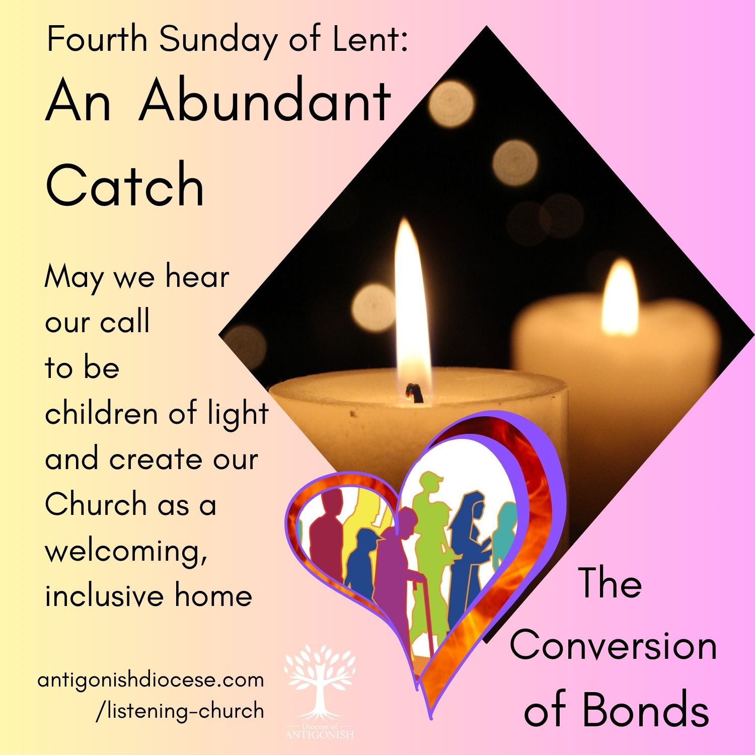
Fourth Sunday of Lent: March 15
Part IV - An Abundant Catch
The Conversion of Bonds
Reflection/Homily Notes
As we gather on this Laetare Sunday, a day of joyful anticipation within our Lenten journey, we are called to reflect not only on the healing of the man born blind but also on the deeper spiritual insight that this Gospel invites us to embrace. In John 9, Jesus reveals Himself as the Light of the World, illuminating not only physical blindness but also spiritual darkness. This Gospel challenges us to see with the eyes of faith and to recognize the ways in which we ourselves may be blind to the needs, gifts, and callings within our Church communities.
The readings from 1 Samuel, Psalm 23, and Ephesians further remind us that God looks beyond outward appearances to the heart, calling us to live as "children of light." This is profoundly connected to our call as a Church to be a welcoming, inclusive home—akin to a family that recognizes and values each member’s unique gifts and contribution.
In the context of synodality, these themes become especially relevant. A synodal Church is one that walks together in humility and openness, listening to the Spirit and to one another—whether in our parishes, dioceses, or the universal Church. The image of the Church as a home of hospitality and encounter aligns with the synodal journey: a space where diverse voices are heard, where differences are appreciated as opportunities for mutual enrichment, and where the Spirit guides us in discernment.
Our shared mission involves transforming our communities into places of authentic encounter—where the "exchange of gifts" is not merely transactional but a sign of deeper communion rooted in evangelical solidarity. As bishops and clergy, we are called to foster environments—whether in parishes, diocesan meetings, or ecumenical dialogues—that promote life, action, prayer, and genuine dialogue.
Furthermore, the principle of the bonds of unity emphasizes that each local Church moves at its own pace, yet all are called to journey together, sharing gifts and learning from one another. This diversity, when rooted in humility and mutual respect, becomes a source of strength for our mission.
In closing, let us ask ourselves: Are we truly seeing with the eyes of faith? Are we listening as a Church called to be a home of welcome, a school of communion, and a pilgrim community on mission? As we continue along this Lenten path, may the Light of Christ dispel our spiritual blindness, inspiring us to be a more synodal Church—one that walks together in hope, rooted in love and open to the Spirit’s guiding.
Prayers of the Faithful
For Spiritual Sight: That the Lord may open our eyes to see our own limitations, that we may move away from clericalism and embrace a truly synodal way of being Church where everyone has a part. We pray to the Lord.

For Joy in Repentance: That this "Laetare" Sunday may fill us with joy, and that we may turn away from division and toward a deeper, shared communion. We pray to the Lord.
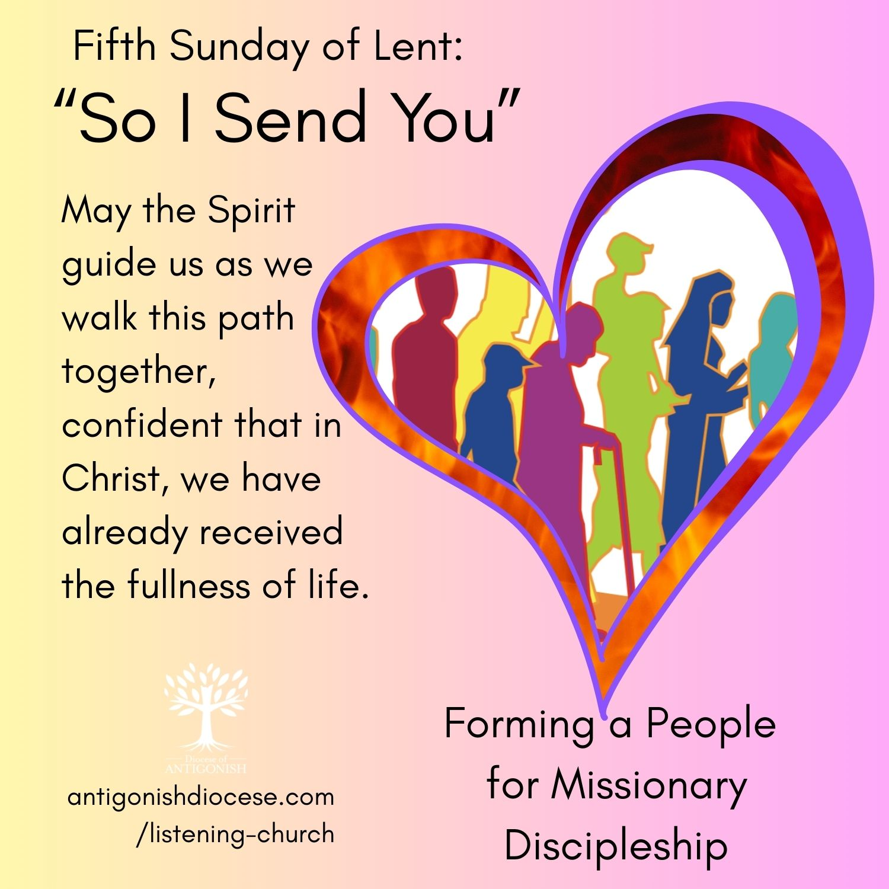
Fifth Sunday of Lent: March 22
Collection Sunday, Development and Peace
Part V - “So I Send You”
Forming a People for Missionary Discipleship
Reflection/Homily Notes
As we gather on this Fifth Sunday of Lent, our readings invite us to reflect deeply on the promise of new life, the power of the Spirit, and the call to resurrection—not only as individuals but as a community of faith. Ezekiel’s vision of God opening the graves and breathing life into His people echoes the transformative power of the Holy Spirit dwelling within us, as Paul reminds us in Romans. Jesus’ declaration in John’s Gospel, “I am the resurrection and the life,” confronts us with the reality that new life is rooted in Him, the source of all hope and renewal.
These themes are not only personal but communal. They challenge us to consider what it means to be a Church that embodies resurrection—alive, vibrant, and committed to life-giving missions in the world.
In our current journey towards becoming a more synodal Church, these Gospel themes serve as a vital foundation. Synodality calls us to walk together, to listen deeply, and to discern the Spirit’s guidance as a community. It is about shared participation—men and women, laity and clergy, young and old—collaborating in the mission of the Church.
The synodal process emphasizes a “common and shared formation,” where every member’s voice contributes to the discernment of how we can more effectively live the Gospel. It recognizes that the Spirit dwells within all of us, animating our collective journey of faith, hope, and love.
Becoming missionary disciples is an ongoing process of conversion—growing in love and openness to the Spirit’s gifts. As shepherds of the flock, we are called to facilitate this growth, fostering environments where everyone can deepen their understanding of their baptismal calling.
In the light of the readings, our mission extends beyond personal salvation to social transformation. The Church’s social doctrine urges us to be attentive to the suffering of victims and survivors, to promote justice and peace, and to care for our common home. These actions are integral to our evangelizing mission and are expressions of resurrection life in today’s world.
The Gospel story of Lazarus also reminds us that resurrection involves proximity—being present to those who suffer, supporting victims, and practicing compassion. Synodality requires us to listen to the stories of those on the margins, to allow their suffering to move us closer to a more just and merciful Church.
Brothers and sisters, as we journey through Lent towards Easter, let us renew our commitment to be a synodal Church—one that listens, learns, and acts together, inspired by the Spirit of resurrection. Let us be open to conversion, to growth in love, and to the collaborative discernment that shapes our mission. In doing so, we become a Church that truly embodies the life, hope, and renewal promised in these sacred texts.
May the Spirit guide us as we walk this path together, confident that in Christ, we have already received the fullness of life.
Prayers of the Faithful

For New Life in the Church: That as Jesus called Lazarus, he may call our Church to rise from indifference and, through the synodal process, renew our commitment to mission and service. We pray to the Lord.

For Victims of Injustice: That our slow sacrifices may help us stand in solidarity with those suffering from injustice, working together for a more just and loving world. We pray to the Lord.

