April 2026 – Our Clergy
We | 1 | Pope Leo XIV
Th | 2 | Bishop Wayne Kirkpatrick
Fr | 3 | Seminarians
Sa | 4 | Candidates to Permanent Diaconate
Su | 5 | Fr. Dennis Lamey
Mo | 6 | Fr. Peter LeBlanc
Tu | 7 | Deacon David Lewis
We | 8 | Fr. Bernard MacAdam
Th | 9 | Fr. Daniel G. MacDonald
Fr | 10 | Fr. Daniel J. MacDonald
Sa | 11 | Fr. Douglas MacDonald
Su | 12 | Fr. Peter MacDonald
Mo | 13 | Fr. Angus MacDougall
Tu | 14 | Fr. Martin MacDougall
We | 15 | Fr. Everett MacDow
Th | 16 | Fr. Angus MacGillivray
Fr | 17 | Fr. Donald MacGillivray
Sa | 18 | Fr. George MacInnis
Su | 19 | Fr. Duncan MacIsaac
Mo | 20 | Fr. Joseph MacKenzie
Tu | 21 | Fr. Colin MacKinnon
We | 22 | Fr. Daniel MacLennan
Th | 23 | Fr. Allan MacMillan
Fr | 24 | Fr. Everett MacNeil
Sa | 25 | Deacon Lorne MacNeil
Su | 26 | Fr. Tom MacNeil
Mo | 27 | Fr. Norman MacPhee
Tu | 28 | Fr. Gary MacPherson
We | 29 | Fr. Allan MacPhie
Th | 30 | Deacon Duncan McMaster


Daily Prayers
Diocese of Antigonish

Please Pray for a Clergy
and Community Each Day



Let us pray for priests and deacons:

The Holy Father
Fill him with your grace, Lord.
Our Bishop Those who are worried
Give him your gifts, Lord Give them peace, Lord
Diocesan Priests and Deacons Those who are old
Never leave them, Lord Sustain them, Lord.
Priests in seminary work Those who are young
Give them your wisdom, Lord Impel them for your glory, Lord.
Those in hospital work Those who are alone
Give them constancy, Lord Accompany them, Lord.
Those who are ill Missionary Priests
Heal them, Lord. Protect them, Lord.
Those who are in danger Those who preach
Deliver them, Lord. Enlighten them, Lord.
Those who are weak Those who direct souls
Strengthen them, Lord. Instruct them, Lord.
Those who are poor Parish priests
Relieve them, Lord Give them prudence, Lord.
Those who are zealous On all the Church
Help them, Lord. ---Lord, have mercy

April 2026 – Our Communities
We | 1 | Glencoe Mills
Th | 2 | Glendale
Fr | 3 | Grand Mira
Sa | 4 | Guysborough
Su | 5 | Guysborough Intervale
Mo | 6 | Havre Boucher
Tu | 7 | Heatherton
We | 8 | Ingonish
Th | 9 | Inverness
Fr | 10 | Iona
Sa | 11 | Johnstown
Su | 12 | Judique
Mo | 13 | Lakevale
Tu | 14 | L’Ardoise
We | 15 | Larry’s River
Th | 16 | Lincolnville
Fr | 17 | Lismore
Sa | 18 | Little Bras d’Or
Su | 19 | Little Dover
Mo | 20 | Lochaber
Tu | 21 | Louisbourg
We | 22 | Louisdale
Th | 23 | Lower River Inhabitants
Fr | 24 | Mabou
Sa | 25 | Main-a-Dieu
Su | 26 | East Margaree
Mo | 27 | Northeast Margaree
Tu | 28 | Southwest Margaree
We | 29 | Maryvale
Th | 30 | Marion Bridge

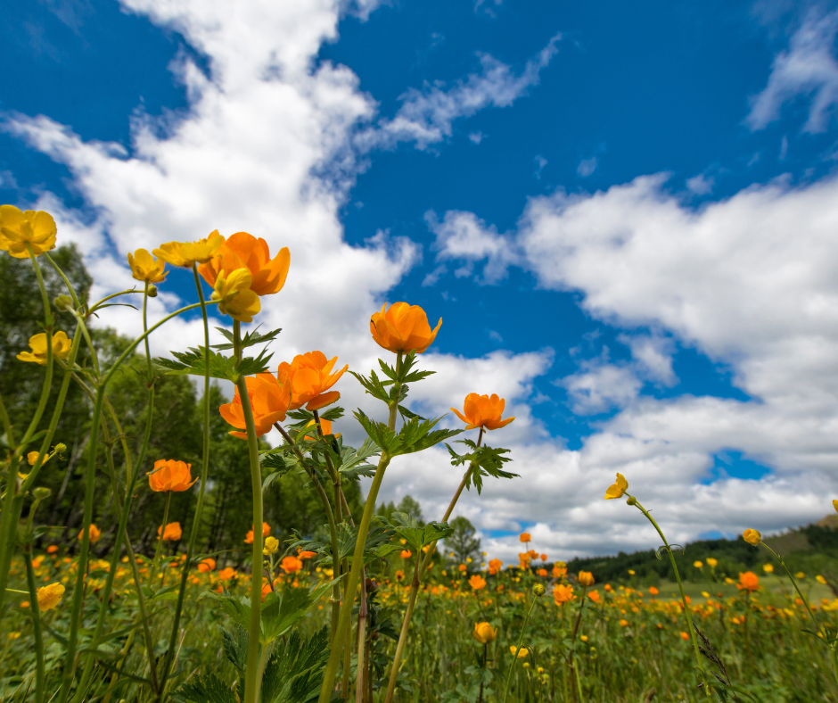

Embracing Father,
You grace each of us with equal measure in your love.
Let us learn to love our neighbours more deeply,
so that we can create
peaceful and just communities.
Inspire us to use our creative energies
to build the structures we need
to overcome the obstacles
of intolerance and indifference.
May Jesus provide us the example needed
and send the Spirit to warm our hearts for the journey.
Amen
—from Being Neighbor: The Catechism and Social Justice
https://www.usccb.org/prayer-and-worship/prayers-and-devotions/prayers/prayer-for-community

We invite you to use these prayers, offer your own prayers, or offer up Mass, Fasting, Eucharistic Exposition, Rosary. Holy Hour or other devotions. Thank you for helping to spread God’s healing love.

