June 2026 – Our Clergy
Mo | 1 | Pope Leo XIV
Tu | 2 | Bishop Wayne Kirkpatrick
We | 3 | Seminarians
Th | 4 | Candidates to Permanent Diaconate
Fr | 5 | Fr. Antolin Asor
Sa | 6 | Fr. Joby Augustin
Su | 7 | Fr. John Barry
Mo | 8 | Deacon Shawn Bigley
Tu | 9 | Fr. Daniel Boudreau
We | 10 | Fr. Donald Boudreau
Th | 11 | Deacon Fernand Boivin
Fr | 12 | Fr. Andrew Boyd
Sa | 13 | Fr. Bill Burke
Su | 14 | Deacon Sander Burke
Mo | 15 | Fr. Charles Cameron
Tu | 16 | Fr. Jaison Cheriya
We | 17 | Fr. Barrett Clare-Johnson
Th | 18 | Deacon Robert Coleman
Fr | 19 | Fr. Duaine Devereaux
Sa | 20 | Fr. Evo DiPierro
Su | 21 | Fr. Daniel Doucet
Mo | 22 | Fr. Bedford Doucette
Tu | 23 | Deacon Michael Doyle
We | 24 | Fr. Anthony Eboh
Th | 25 | Fr. Conrad Edwards
Fr | 26 | Fr. Vincent Emezue
Sa | 27 | Fr. Andrew Gillies
Su | 28 | Deacon Berkley Guthro
Mo | 29 | Fr. Raymond Huntley
Tu | 30 | Fr. Macdonald Ibeh


Daily Prayers
Diocese of Antigonish

Please Pray for a Clergy
and Community Each Day



Let us pray for priests and deacons:

The Holy Father
Fill him with your grace, Lord.
Our Bishop Those who are worried
Give him your gifts, Lord Give them peace, Lord
Diocesan Priests and Deacons Those who are old
Never leave them, Lord Sustain them, Lord.
Priests in seminary work Those who are young
Give them your wisdom, Lord Impel them for your glory, Lord.
Those in hospital work Those who are alone
Give them constancy, Lord Accompany them, Lord.
Those who are ill Missionary Priests
Heal them, Lord. Protect them, Lord.
Those who are in danger Those who preach
Deliver them, Lord. Enlighten them, Lord.
Those who are weak Those who direct souls
Strengthen them, Lord. Instruct them, Lord.
Those who are poor Parish priests
Relieve them, Lord Give them prudence, Lord.
Those who are zealous On all the Church
Help them, Lord. ---Lord, have mercy

June 2026 – Our Communities
Mo | 1 | Waycobah
Tu | 2 | West Bay Road
We | 3 | Westmount
Th | 4 | Westville
Fr | 5 | Whitney Pier
Sa | 6 | Albert Bridge
Su | 7 | Alder Point
Mo | 8 | Antigonish
Tu | 9 | Arichat
We | 10 | Arisaig
Th | 11 | Baddeck
Fr | 12 | Ballantyne’s Cove
Sa | 13 | Barra Head
Su | 14 | Big Pond
Mo | 15 | Boisdale
Tu | 16 | Boularderie
We | 17 | Bras d’Or
Th | 18 | Bridgeport
Fr | 19 | Broad Cove
Sa | 20 | Brook Village
Su | 21 | Canso
Mo | 22 | Cheticamp
Tu | 23 | Creignish
We | 24 | Dingwall
Th | 25 | Donkin
Fr | 26 | East Bay
Sa | 27 | Eskasoni
Su | 28 | Frenchvale
Mo | 29 | Giants Lake
Tu | 30 | Georgeville

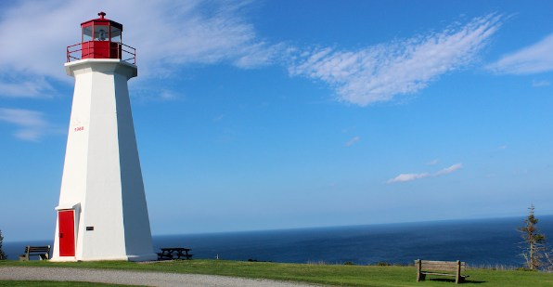

Embracing Father,
You grace each of us with equal measure in your love.
Let us learn to love our neighbours more deeply,
so that we can create
peaceful and just communities.
Inspire us to use our creative energies
to build the structures we need
to overcome the obstacles
of intolerance and indifference.
May Jesus provide us the example needed
and send the Spirit to warm our hearts for the journey.
Amen

—from Being Neighbor: The Catechism and Social Justice
https://www.usccb.org/prayer-and-worship/prayers-and-devotions/prayers/prayer-for-community

We invite you to use these prayers, offer your own prayers, or offer up Mass, Fasting, Eucharistic Exposition, Rosary. Holy Hour or other devotions. Thank you for helping to spread God’s healing love.

