August 2026 – Our Clergy
Sa | 1 | Pope Leo XIV
Su | 2 | Bishop Wayne Kirkpatrick
Mo | 3 | Seminarians
Tu | 4 | Candidates to Permanent Diaconate
We | 5 | Fr. Allan MacPhie
Th | 6 | Deacon Duncan McMaster
Fr | 7 | Fr. Albert Maroun
Sa | 8 | Deacon Barry Miller
Su | 9 | Fr. Eugene Morris
Mo | 10 | Fr. John Morrison
Tu | 11 | Fr. Douglas Murphy
We | 12 | Deacon Greg Murphy
Th | 13 | Fr. Paul Murphy
Fr | 14 | Fr. Jonathan Nnajiofor
Sa | 15 | Fr. Anthony O’Connor
Su | 16 | Fr. Godwin Obike
Mo | 17 | Fr. James Oliver
Tu | 18 | Fr. Thaddeus Orga
We | 19 | Fr. Victor Ozonoh
Th | 20 | Fr. Frank Pellerin
Fr | 21 | Deacon Leo Penny
Sa | 22 | Fr. David Rankin
Su | 23 | Deacon Art Riley
Mo | 24 | Fr. Sunny Sebastian
Tu | 25 | Deacon Roy Smith
We | 26 | Deacon Tom Sylliboy
Th | 27 | Fr. Daniel Tshimbalanga
Fr | 28 | Fr. Jonas Uwaezuoke
Sa | 29 | Deacon Henry Van De Wiel
Su | 30 | Fr. John Yake
Mo | 31 | Fr. Chinonso Alaribe


Daily Prayers
Diocese of Antigonish

Please Pray for a Clergy
and Community Each Day

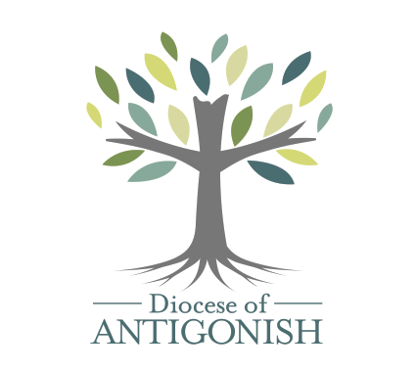

Let us pray for priests and deacons:

The Holy Father
Fill him with your grace, Lord.
Our Bishop Those who are worried
Give him your gifts, Lord Give them peace, Lord
Diocesan Priests and Deacons Those who are old
Never leave them, Lord Sustain them, Lord.
Priests in seminary work Those who are young
Give them your wisdom, Lord Impel them for your glory, Lord.
Those in hospital work Those who are alone
Give them constancy, Lord Accompany them, Lord.
Those who are ill Missionary Priests
Heal them, Lord. Protect them, Lord.
Those who are in danger Those who preach
Deliver them, Lord. Enlighten them, Lord.
Those who are weak Those who direct souls
Strengthen them, Lord. Instruct them, Lord.
Those who are poor Parish priests
Relieve them, Lord Give them prudence, Lord.
Those who are zealous On all the Church
Help them, Lord. ---Lord, have mercy

August 2026 – Our Communities
Sa | 1 | Membertou
Su | 2 | Mulgrave
Mo | 3 | New Glasgow
Tu | 4 | New Waterford
We | 5 | North Sydney
Th | 6 | Paqtnkek
Fr | 7 | Petit-de-grat
Sa | 8 | Pictou
Su | 9 | Pictou Landing
Mo | 10 | Pomquet
Tu | 11 | Port Felix
We | 12 | Port Hawkesbury
Th | 13 | Port Hood
Fr | 14 | Port Morien
Sa | 15 | Potlotek
Su | 16 | Queensport
Mo | 17 | Reserve Mines
Tu | 18 | River Bourgeois
We | 19 | Salmon River Lake
Th | 20 | St. Andrew’s
Fr | 21 | St. Francis Harbour
Sa | 22 | St. Joseph’s
Su | 23 | St. Joseph du Moine
Mo | 24 | St. Margaret’s Village
Tu | 25 | St. Peter
We | 26 | Sherbrooke
Th | 27 | Stellarton
Fr | 28 | Tracadie
Sa | 29 | Sydney
Su | 30 | Sydney Mines
Mo | 31 | Sydney River

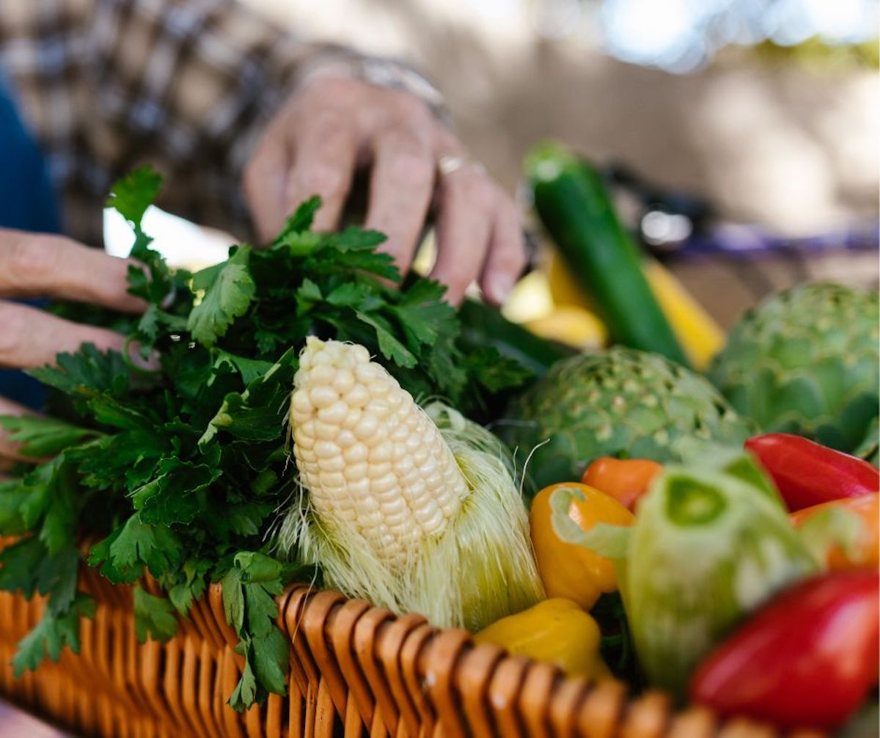

Embracing Father,
You grace each of us with equal measure in your love.
Let us learn to love our neighbours more deeply,
so that we can create
peaceful and just communities.
Inspire us to use our creative energies
to build the structures we need
to overcome the obstacles
of intolerance and indifference.
May Jesus provide us the example needed
and send the Spirit to warm our hearts for the journey.
Amen

—from Being Neighbor: The Catechism and Social Justice
https://www.usccb.org/prayer-and-worship/prayers-and-devotions/prayers/prayer-for-community

We invite you to use these prayers, offer your own prayers, or offer up Mass, Fasting, Eucharistic Exposition, Rosary. Holy Hour or other devotions. Thank you for helping to spread God’s healing love.

