September 2026 – Our Clergy
Tu | 1 | Pope Leo XIV
We | 2 | Bishop Wayne Kirkpatrick
Th | 3 | Seminarians
Fr | 4 | Candidates to Permanent Diaconate
Sa | 5 | Fr. Rowland Agomuo
Su | 6 | Fr. Macleen Anyanwu
Mo | 7 | Fr. Antolin Asor
Tu | 8 | Fr. Joby Augustin
We | 9 | Fr. John Barry
Th | 10 | Deacon Shawn Bigley
Fr | 11 | Fr. Daniel Boudreau
Sa | 12 | Fr. Donald Boudreau
Su | 13 | Deacon Fernand Boivin
Mo | 14 | Fr. Andrew Boyd
Tu | 15 | Fr. Bill Burke
We | 16 | Deacon Sander Burke
Th | 17 | Fr. Charles Cameron
Fr | 18 | Fr. Jaison Cheriya
Sa | 19 | Fr. Jaison Cherumadathil
Su | 20 | Fr. Barrett Clare-Johnson
Mo | 21 | Deacon Robert Coleman
Tu | 22 | Fr. Duaine Devereaux
We | 23 | Fr. Evo Di Pierro
Th | 24 | Fr. Daniel Doucet
Fr | 25 | Fr. Bedford Doucette
Sa | 26 | Deacon Michaael Doyle
Su | 27 | Fr. Anthony Eboh
Mo | 28 | Fr. Conrad Edwards
Tu | 29 | Fr. Vincent Emezue
We | 30 | Fr. Andrew Gillies


Daily Prayers
Diocese of Antigonish

Please Pray for a Clergy
and Community Each Day



Let us pray for priests and deacons:

The Holy Father
Fill him with your grace, Lord.
Our Bishop Those who are worried
Give him your gifts, Lord Give them peace, Lord
Diocesan Priests and Deacons Those who are old
Never leave them, Lord Sustain them, Lord.
Priests in seminary work Those who are young
Give them your wisdom, Lord Impel them for your glory, Lord.
Those in hospital work Those who are alone
Give them constancy, Lord Accompany them, Lord.
Those who are ill Missionary Priests
Heal them, Lord. Protect them, Lord.
Those who are in danger Those who preach
Deliver them, Lord. Enlighten them, Lord.
Those who are weak Those who direct souls
Strengthen them, Lord. Instruct them, Lord.
Those who are poor Parish priests
Relieve them, Lord Give them prudence, Lord.
Those who are zealous On all the Church
Help them, Lord. ---Lord, have mercy

September 2026 – Our Communities
Tu | 1 | Wagmatcook
We | 2 | Waycobah
Th | 3 | West Bay Road
Fr | 4 | Westmount
Sa | 5 | Westville
Su | 6 | Whitney Pier
Mo | 7 | Albert Bridge
Tu | 8 | Alder Point
We | 9 | Antigonish
Th | 10 | Arichat
Fr | 11 | Arisaig
Sa | 12 | Baddeck
Su | 13 | Ballantyne’s Cove
Mo | 14 | Barra Head
Tu | 15 | Big Pond
We | 16 | Boisdale
Th | 17 | Boularderie
Fr | 18 | Bras d’Or
Sa | 19 | Bridgeport
Su | 20 | Broad Cove
Mo | 21 | Brook Village
Tu | 22 | Canso
We | 23 | Cheticamp
Th | 24 | Creignish
Fr | 25 | Dingwall
Sa | 26 | Donkin
Su | 27 | East Bay
Mo | 28 | Eskasoni
Tu | 29 | Frenchvale
We | 30 | Giants Lake

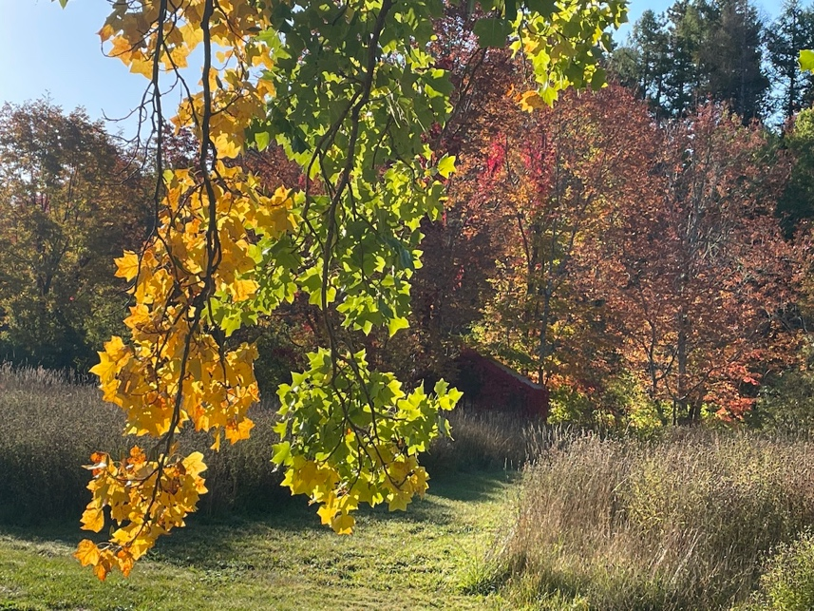

Embracing Father,
You grace each of us with equal measure in your love.
Let us learn to love our neighbours more deeply,
so that we can create
peaceful and just communities.
Inspire us to use our creative energies
to build the structures we need
to overcome the obstacles
of intolerance and indifference.
May Jesus provide us the example needed
and send the Spirit to warm our hearts for the journey.
Amen

—from Being Neighbor: The Catechism and Social Justice
https://www.usccb.org/prayer-and-worship/prayers-and-devotions/prayers/prayer-for-community

We invite you to use these prayers, offer your own prayers, or offer up Mass, Fasting, Eucharistic Exposition, Rosary. Holy Hour or other devotions. Thank you for helping to spread God’s healing love.

