October 2026 – Our Clergy
Th | 1 | Pope Leo XIV
Fr | 2 | Bishop Wayne Kirkpatrick
Sa | 3 | Seminarians
Su | 4 | Candidates to Permanent Diaconate
Mo | 5 | Deacon Berkley Guthro
Tu | 6 | Fr. Raymond Huntley
We | 7 | Fr. Macdonald Ibeh
Th | 8 | Fr. Fabian Ihunegbo
Fr | 9 | Deacon Walter Ivany
Sa | 10 | Fr. Alphonsus Iwuji
Su | 11 | Fr. Godwin Kalu
Mo | 12 | Fr. Dennis Lamey
Tu | 13 | Fr. Peter LeBlanc
We | 14 | Deacon David Lewis
Th | 15 | Fr. Bernard MacAdam
Fr | 16 | Fr. Daniel G. MacDonald
Sa | 17 | Fr. Daniel J. MacDonald
Su | 18 | Fr. Douglas MacDonald
Mo | 19 | Fr. Peter MacDonald
Tu | 20 | Fr. Angus MacDougall
We | 21 | Fr. Martin MacDougall
Th | 22 | Fr. Everett MacDow
Fr | 23 | Fr. Angus MacGillivray
Sa | 24 | Fr. Donald MacGillivray
Su | 25 | Fr. George MacInnis
Mo | 26 | Fr. Duncan MacIsaac
Tu | 27 | Fr. Joseph MacKenzie
We | 28 | Fr. Colin MacKinnon
Th | 29 | Fr. Daniel MacLennan
Fr | 30 | Fr. Allan MacMillan
Sa | 31 | Fr. Everett MacNeil


Daily Prayers
Diocese of Antigonish

Please Pray for a Clergy
and Community Each Day



Let us pray for priests and deacons:

The Holy Father
Fill him with your grace, Lord.
Our Bishop Those who are worried
Give him your gifts, Lord Give them peace, Lord
Diocesan Priests and Deacons Those who are old
Never leave them, Lord Sustain them, Lord.
Priests in seminary work Those who are young
Give them your wisdom, Lord Impel them for your glory, Lord.
Those in hospital work Those who are alone
Give them constancy, Lord Accompany them, Lord.
Those who are ill Missionary Priests
Heal them, Lord. Protect them, Lord.
Those who are in danger Those who preach
Deliver them, Lord. Enlighten them, Lord.
Those who are weak Those who direct souls
Strengthen them, Lord. Instruct them, Lord.
Those who are poor Parish priests
Relieve them, Lord Give them prudence, Lord.
Those who are zealous On all the Church
Help them, Lord. ---Lord, have mercy

October 2026 – Our Communities
Th | 1 | Georgeville
Fr | 2 | Glace Bay
Sa | 3 | Glencoe Mills
Su | 4 | Glendale
Mo | 5 | Grand Mira
Tu | 6 | Guysborough
We | 7 | Guysborough Intervale
Th | 8 | Havre Boucher
Fr | 9 | Heatherton
Sa | 10 | Ingonish
Su | 11 | Inverness
Mo | 12 | Iona
Tu | 13 | Johnstown
We | 14 | Judique
Th | 15 | Lakevale
Fr | 16 | L’Ardoise
Sa | 17 | Larry’s River
Su | 18 | Lincolnville
Mo | 19 | Lismore
Tu | 20 | Little Bras d’Or
We | 21 | Little Dover
Th | 22 | Lochaber
Fr | 23 | Louisbourg
Sa | 24 | Louisdale
Su | 25 | Lower River Inhabitants
Mo | 26 | Mabou
Tu | 27 | Main-a-dieu
We | 28 | East Margaree
Th | 29 | Northeast Margaree
Fr | 30 | Southwest Margaree
Sa | 31 | Maryvale

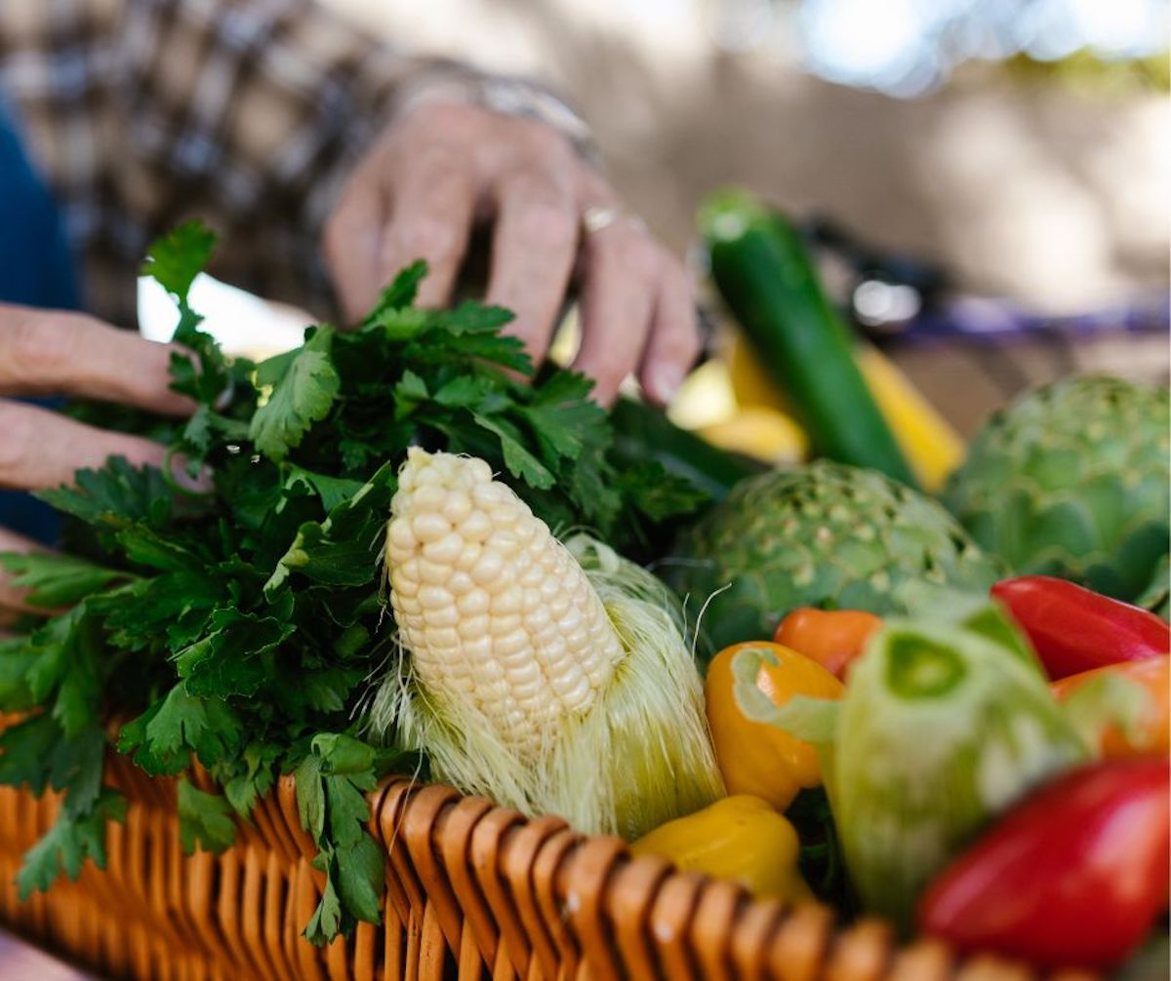

Embracing Father,
You grace each of us with equal measure in your love.
Let us learn to love our neighbours more deeply,
so that we can create
peaceful and just communities.
Inspire us to use our creative energies
to build the structures we need
to overcome the obstacles
of intolerance and indifference.
May Jesus provide us the example needed
and send the Spirit to warm our hearts for the journey.
Amen

—from Being Neighbor: The Catechism and Social Justice
https://www.usccb.org/prayer-and-worship/prayers-and-devotions/prayers/prayer-for-community

We invite you to use these prayers, offer your own prayers, or offer up Mass, Fasting, Eucharistic Exposition, Rosary. Holy Hour or other devotions. Thank you for helping to spread God’s healing love.

